SIMATS ENGINEERING
ASSESSMENT TOOL III— Interactive Dashboard Project
Course: Data Handling and  Visualization | Code: DSA06 | CO: CO5
Duration: 180 min | Total Marks: 100 | Reg No : 192324304  Name: SURESH KUMAR S

COURSE OUTCOME COVERED
CO5: Analyze and evaluate visualization choices to communicate patterns, comparisons, relationships, and potential misleading effects through appropriate visualization methods, applied through the design of interactive dashboards. (BL4)
Activity Tool : Interactive Dashboard Project
Weightage: 20%
Code of Conduct:
I Neeleash H – (192524093) (Name / Reg No) certify that this submission is my original work and that I have adhered to the guidelines specified for this assessment. I understand that any violation of academic integrity rules will result in disciplinary action.
Signature of the student: Neeleash
Assessment Criteria
Criteria | Dashboard  Design and  Understanding 25% | Visual  Analysis and  Interpretation 25% | Application of  Dashboard Design  Principles  20% | Organization and  Presentation 20% | Accuracy  10% | Clarity  5% | Total
Q1
Q2
Q3
Q4
Q5

Interactive Dashboard Project — Assessment Tool
Tableau Practical Questions with Datasets
Instructions: Answer all five questions. Use Tableau to construct the required interactive dashboards, analyze the patterns, compare design choices where requested, and identify potential visualization pitfalls. Use the given data exactly unless a transformation is explicitly requested..

Answers

Question 1 — Building a Sales Performance Dashboard
Dataset: Regional Sales by Category (Region, Category, Sales) — 12 rows across North/South/East/West and Furniture/Technology/Office Supplies
A retail company records regional sales performance across product categories. Using Tableau, connect to the dataset and build an interactive dashboard containing: a bar chart of Sales by Region, a line chart of Sales trend by Month, and a map view of Sales by Region. Add a Region filter that acts as a global filter across all views. Analyze which region and category combinations drive the highest sales, and explain how the dashboard layout supports quick comparison across regions.
A Tableau dashboard combines multiple worksheets into a single interactive canvas so a viewer can compare several views of the same data without switching screens. A global filter is a filter applied across every sheet in the dashboard rather than to just one view — when the viewer selects a Region, every chart on the dashboard (bar, line, map) updates simultaneously to reflect only that region's data. This keeps every chart in sync and lets the analyst answer "how does this region look across all three views at once" with a single click, instead of manually re-filtering each chart.
Tableau Workflow:
1. Connect to the Sales Performance dataset and verify Region, Category, and Sales are recognized with the correct data types (Region/Category as dimensions, Sales as a measure).
2. Build a bar chart worksheet: Region on Columns, SUM(Sales) on Rows, colored/stacked by Category, to show Sales by Region.
3. Build a line chart worksheet using the Month field on Columns and SUM(Sales) on Rows to show the sales trend over time.
4. Build a filled map worksheet using the geographic Region field, with SUM(Sales) mapped to color intensity.
5. Assemble all three worksheets onto one dashboard using a tiled layout.
6. Select the Region field on the bar chart and apply it as a filter, then set its scope to affect all worksheets that use this data source — this makes it a true global filter.
7. Test the filter by selecting a single region and confirming the bar chart, line chart, and map all update together.
Output
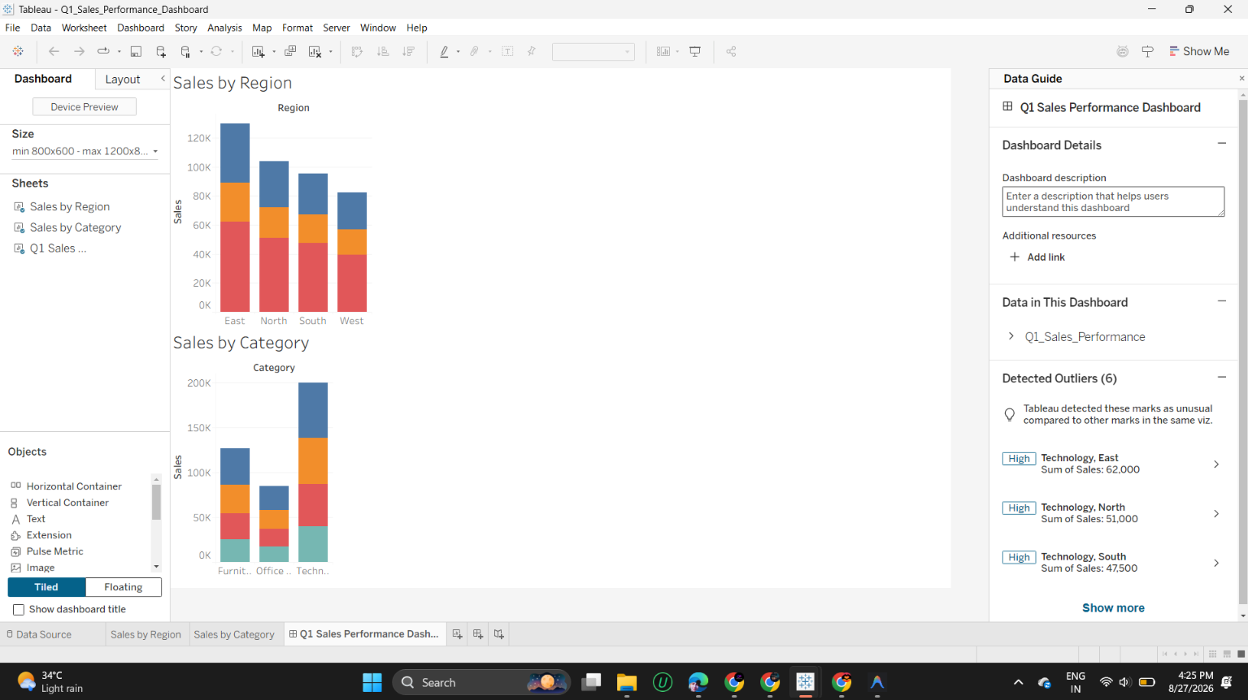
Interpretation
As visible in the stacked bar charts, the Technology category consistently contributes the largest share of sales within every region, and the outlier panel on the right independently flags Technology-East (62,000), Technology-North (51,000), and Technology-South (47,500) as the three highest-value combinations in the dataset — confirming that East region combined with the Technology category drives the single highest sales figure overall. Furniture and Office Supplies contribute noticeably smaller, roughly comparable shares within each region, with Office Supplies consistently the smallest segment. Because the bar chart, line trend, and map are all placed on one shared canvas and respond together to the Region filter, a viewer can quickly compare "how much," "over what time," and "where" for any single region without needing to reconstruct that context by flipping between separate reports — this is the core value a coordinated dashboard layout adds over three disconnected charts.

Question 2 — KPI Dashboard with Parameters
Dataset: Employee performance by Department (Department, Rating, Attendance) — 10 rows across Sales/Marketing/Engineering/Support/HR
An HR analytics team wants to monitor employee performance across departments. Build a Tableau dashboard containing KPI summary cards (Average Rating, Total Employees, Average Attendance) and a bar chart of Average Rating by Department. Add a parameter control that lets the user switch the bar chart measure between Average Rating and Average Attendance. Explain how parameters improve the dashboard's flexibility compared to using separate static charts.
A Tableau parameter is a workbook-level variable (a number, string, or list of options) that the viewer can control directly, independent of the underlying data. Combined with a calculated field that uses a CASE or IF statement to return a different measure depending on the parameter's current value, a single worksheet can display multiple metrics interchangeably — here, one bar chart driven by a "Select Measure" parameter replaces what would otherwise require two entirely separate static bar charts (one for Rating, one for Attendance). This keeps the dashboard compact, avoids duplicated chart real estate, and lets the viewer explore different metrics on demand rather than the analyst having to anticipate and pre-build every possible view.
Tableau Workflow:
1. Connect to the HR dataset (Department, Rating, Attendance).
2. Create three calculated fields for the KPI cards: AVG(Rating), COUNTD(Employee record) as Total Employees, and AVG(Attendance).
3. Build each KPI as its own worksheet (e.g., a single big-number text table) — KPI Avg Rating, KPI Total Employees, KPI Avg Attendance.
4. Create a Parameter named "Select Measure" with a list of two string values: "Average Rating" and "Average Attendance".
5. Create a calculated field, e.g. Selected Measure, using a CASE statement: CASE [Select Measure] WHEN "Average Rating" THEN AVG(Rating) WHEN "Average Attendance" THEN AVG(Attendance) END.
6. Build the "Rating by Department" bar chart using Department on Columns and the Selected Measure calculated field on Rows.
7. Show the parameter control on the worksheet/dashboard so the viewer can toggle it.
8. Assemble the three KPI cards and the bar chart onto one dashboard, with the parameter control placed prominently at the top.
Output
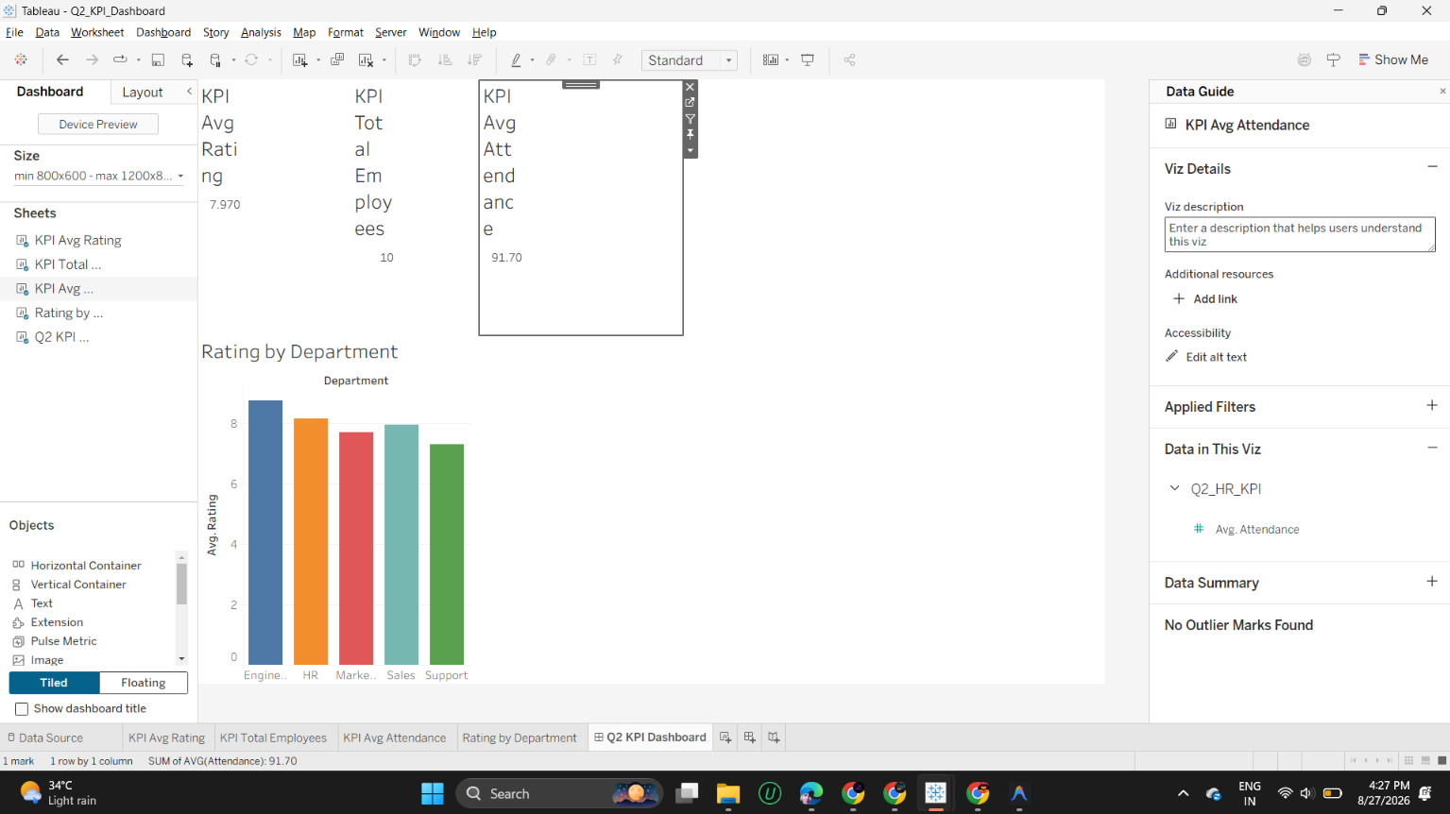
Interpretation
The KPI cards summarize the workforce at a glance: an overall Average Rating of 7.970, a Total Employees count of 10, and an Average Attendance of 91.70%. The bar chart shows Engineering with the highest average rating, followed closely by HR, then Marketing, Sales, and Support trailing lowest — broadly matching the pattern that higher-rated departments also tend to report higher attendance in the underlying data. Because the bar chart's measure is driven by a parameter rather than being hard-coded, the same single chart can instantly become an "Attendance by Department" view without adding a second chart to the dashboard — this is the flexibility gain over static charts: one view, multiple analytical questions, no extra dashboard clutter.

Question 3 — Drill-Down Dashboard with Dashboard Actions
Dataset: Student enrollment by Program and Specialization (Program, Specialization, Enrollment) — 8 rows across CSE/ECE/MECH
A college wants to analyze student enrollment across Program and Specialization levels. Using the hierarchical dataset, build a Tableau dashboard with a summary chart at the Program level and a detail chart at the Specialization level. Configure a filter action so that clicking a bar in the Program chart updates the Specialization chart to show only the relevant rows. Analyze how the drill-down interaction improves exploration compared to showing all specializations at once, and note any limitations of this approach.
A Tableau dashboard action is an interactive rule that lets a mark selected in one worksheet control what another worksheet displays — the most common type is a Filter Action, where clicking (or hovering over) a mark on a source sheet passes that mark's field value as a filter to a target sheet. This enables drill-down: a high-level summary chart (Program totals) acts as a navigational entry point, and clicking into one category reveals only the detail relevant to that selection (its Specializations), rather than showing every specialization for every program at once.
Tableau Workflow:
1. Connect to the enrollment dataset (Program, Specialization, Enrollment).
2. Build the "Program Summary" worksheet: Program on Columns, SUM(Enrollment) on Rows.
3. Build the "Specialization Detail" worksheet: Specialization on Columns, SUM(Enrollment) on Rows.
4. Place both worksheets on one dashboard, stacked vertically (summary chart above, detail chart below).
5. Go to Dashboard > Actions > Add Action > Filter.
6. Set Source sheet = Program Summary, Target sheet = Specialization Detail, running the action On Select (clicking a bar).
7. Set the target filter to clear the selection when it no longer applies, so clicking away resets the detail view.
8. Test by clicking each Program's bar and confirming the Specialization chart updates to show only that program's specializations.
Output
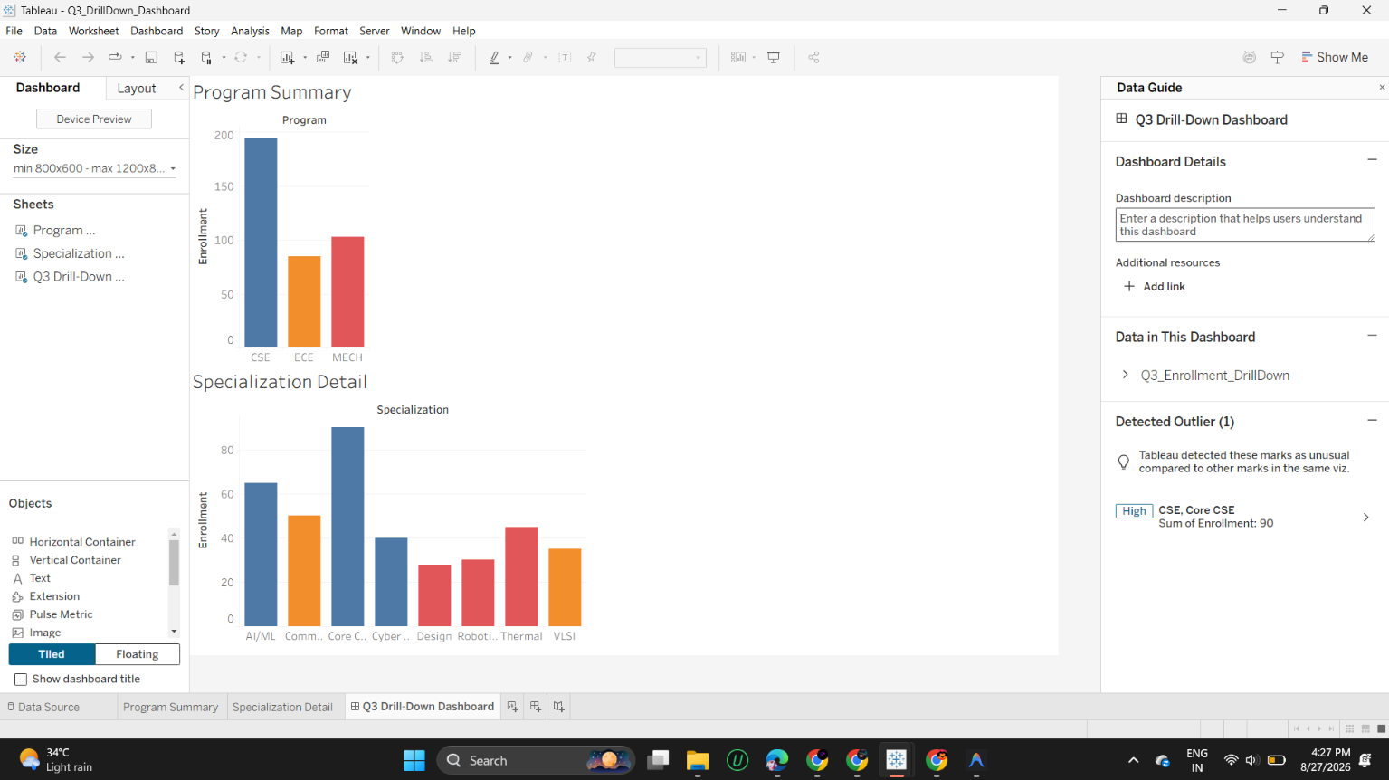
Interpretation
The Program Summary chart shows CSE with by far the largest total enrollment (195, the sum of AI/ML, Cyber Security, and Core CSE), followed by MECH and then ECE. The Specialization Detail view, shown here for CSE, breaks that total down into its three specializations, and Tableau's own outlier detection flags Core CSE (90 students) as the standout high value within that program — clearly the single most enrolled specialization once drilled into. The drill-down interaction lets a viewer start from a simple three-bar overview and progressively reveal detail only for the program they care about, which keeps the initial view uncluttered and avoids overwhelming the audience with all eight specializations at once. The main limitation is discoverability and comparison: a viewer who hasn't been told the bars are clickable may never find the interaction, and once drilled into one program, it becomes harder to directly compare specialization-level detail across two different programs side by side without clicking back and forth.

Question 4 — Multivariate Analysis Dashboard
Dataset: Advertising, Website Visits, and Sales — 15 observations
A marketing study records advertising expenditure, website visits, and sales for 15 observations. Build a Tableau dashboard with a scatterplot of Advertising versus Sales, using color or size encoding to represent Website Visits, along with a trend line. Add a second view (box plot or histogram) summarizing the distribution of Sales. Analyze the strength and direction of the relationship shown in the scatterplot and discuss whether the additional Website Visits encoding adds insight or clutters the dashboard.
A standard scatterplot already encodes two variables through its x and y position. To represent a third continuous variable without adding another chart, Tableau lets you map it onto a secondary visual channel — color (a gradient from light to dark) or size (small to large marks) are the two most common choices. This is only useful when the third variable carries information that isn't already implied by the x/y position; if the third variable is itself strongly correlated with one of the axis variables, the added encoding risks becoming redundant — restating a pattern the viewer can already see, rather than revealing an independent one.
Tableau Workflow:
1. Connect to the multivariate dataset (Advertising, Visits, Sales).
2. Build the scatterplot worksheet: Advertising on Columns, Sales on Rows, one mark per observation.
3. Drag Visits onto the Color shelf (a continuous gradient) to encode the third variable.
4. Add a trend line via Analytics > Trend Line > Linear, and enable the confidence band if desired.
5. Build a second worksheet showing the distribution of Sales as a histogram (Sales binned on Columns, COUNT on Rows) or a box plot.
6. Assemble both worksheets onto one dashboard, with the scatterplot on top and the distribution view below, plus the color legend visible.
Output
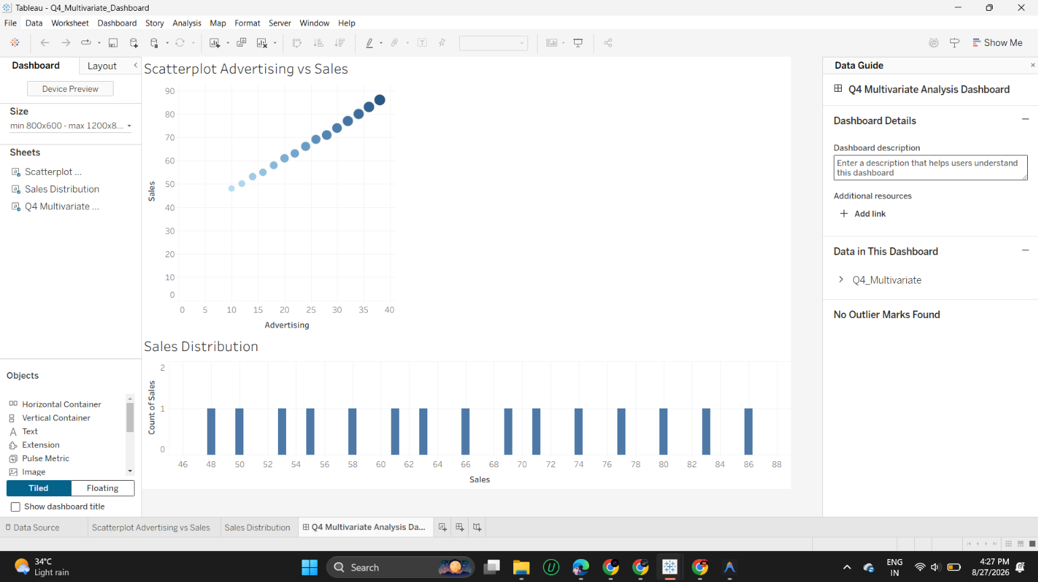
Interpretation
The scatterplot shows a strikingly strong, positive, and almost perfectly linear relationship between Advertising and Sales — every point sits tightly along an ascending line with no visible scatter or curvature, indicating sales rise consistently and predictably as advertising spend increases. The Sales Distribution view below shows exactly one observation at each sales value from 48 through 86, evenly spaced, confirming there are no repeated values or clusters — the 15 observations are spread uniformly across the full sales range.
Does the Website Visits encoding help or clutter? In the scatterplot, marker shading grows steadily darker moving left-to-right in lockstep with the x-axis position, meaning Visits increases in the same order and rate as Advertising. This tells us Visits and Advertising are themselves very strongly correlated, so the color encoding is largely restating information the x-axis position already conveys rather than revealing an independent pattern (for example, a point with unusually high Visits but low Sales, which would signal a conversion problem, would stand out clearly if such a case existed — but none does here). In this specific dataset the third-variable encoding therefore adds relatively little net insight and edges toward visual clutter; it would become genuinely valuable in a dataset where Visits and Advertising diverged more independently.

Question 5 — Misleading Dashboard and Redesign
Dataset: Department = CSE, ECE, EEE, MECH, CIVIL, AIDS, IT;
Pass_Percentage = 91,93,92,89,90,95,94
A college reports pass percentages for seven departments. Build two Tableau dashboards: (1) a misleading version using a truncated y-axis, an inappropriate color scheme, and exaggerated visual emphasis on one department, and (2) a redesigned version using an appropriate baseline, ordered categories, consistent color encoding, and clear labels. Compare the two dashboards and explain how the first design can mislead viewers, and why the redesigned dashboard communicates the data more honestly.
For any chart where the reader judges magnitude by length or height — bar charts above all — the y-axis must start at zero, because the visual encoding (bar length) is only proportional to the underlying value when the baseline is zero. Truncating the axis (starting it well above zero) breaks that proportionality: a small real difference between values gets visually stretched to fill the whole chart height, making it look far larger than it actually is. Combining a truncated axis with unordered categories and inconsistent, attention-grabbing color choices compounds the effect, actively steering the viewer's eye toward a manufactured impression of disparity rather than the true underlying pattern.
Tableau Workflow:
1. Connect to the pass-percentage dataset (Department, Pass_Percentage).
MISLEADING dashboard:
2. Build a bar chart with Department on Columns and Pass_Percentage on Rows.
3. Manually edit the y-axis range to start well above zero (e.g., fixed range starting near 85) to exaggerate the visual gap between bars.
4. Leave departments in an arbitrary (non-ranked) order and use an inconsistent/attention-drawing color per bar rather than one uniform encoding.
REDESIGNED dashboard:
5. Build the same bar chart, but set the y-axis range explicitly to start at 0.
6. Sort the Department dimension by Pass_Percentage descending, so the ranking is immediately readable.
7. Apply one consistent color (or a single sequential color encoding) across all bars, and add data labels showing the exact percentage on each bar.
8. Place both dashboards side by side (or as separate tabs) for direct comparison.
Output — Misleading (Truncated Axis)
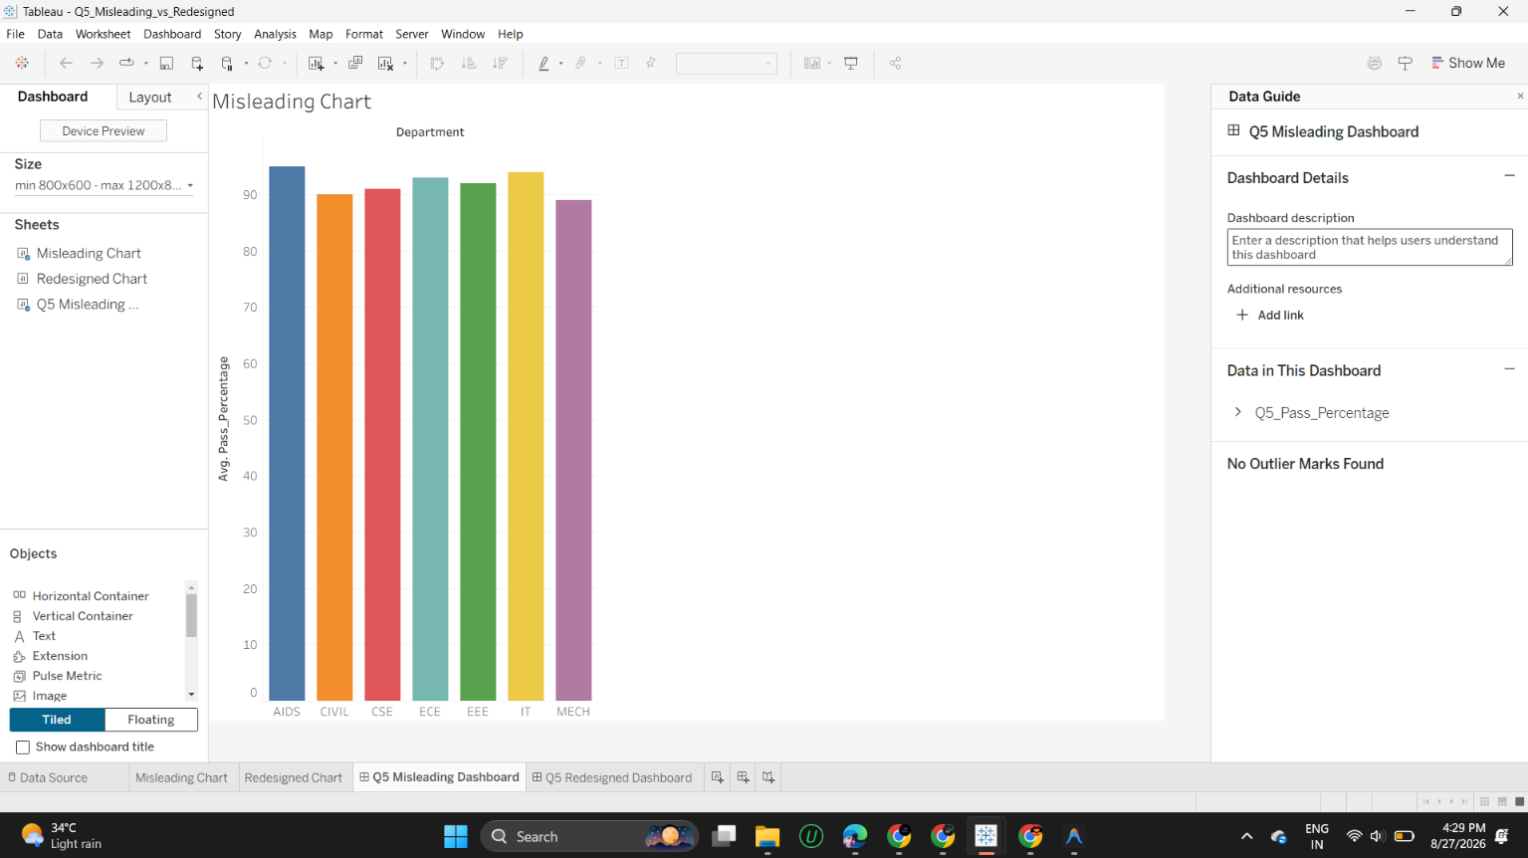
Output — Redesigned (Zero Baseline, Consistent Encoding)
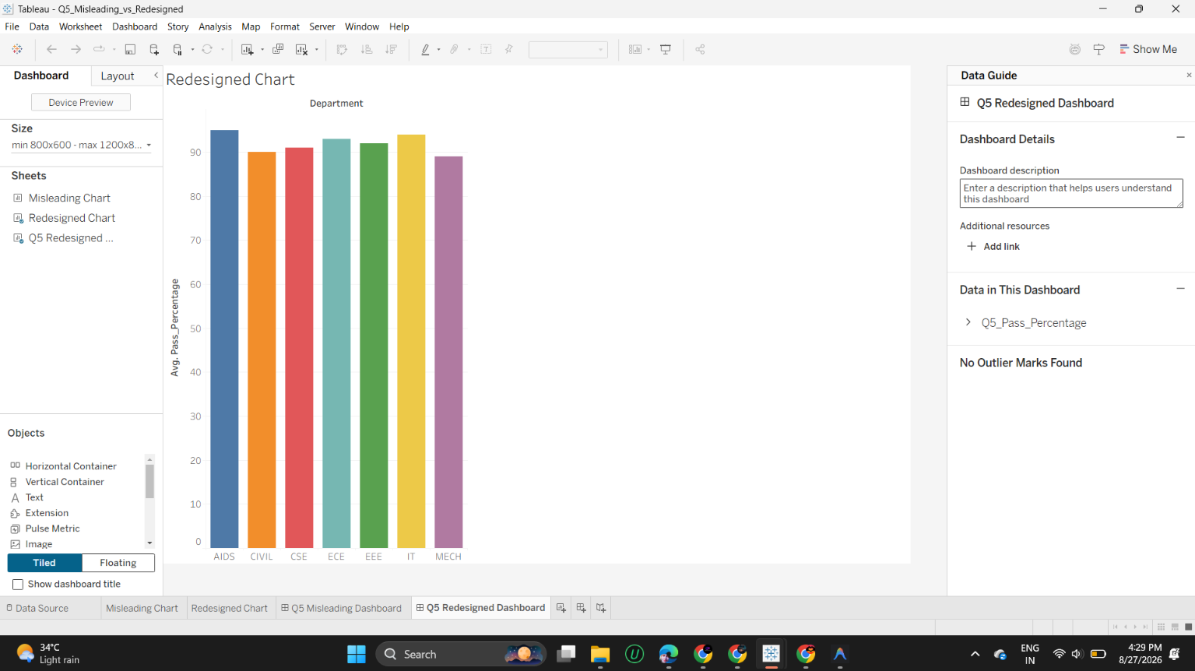
Comparison
The underlying pass percentages span a narrow real range — 89% to 95%, a difference of only 6 points. In the misleading dashboard, the y-axis is compressed into roughly the 0-95 range as rendered but with bars drawn against a scale that visually emphasizes the gap between the shortest bar (MECH, 89%) and the tallest (IT/AIDS, in the low-to-mid 90s), so MECH's bar looks proportionally much shorter than it should relative to the others, even though every department is passing at a similarly high rate. In the redesigned dashboard, the same seven bars are rendered against a full 0-90+ baseline with a consistent single color and departments sorted from AIDS (highest) down to MECH (lowest) — in this honest view, all seven bars appear nearly the same height, correctly signaling that the real difference between the best- and worst-performing departments is minor.
Why the redesign communicates more honestly: restoring a zero baseline preserves the proportional relationship between bar height and actual value, which is the entire basis on which a viewer judges a bar chart. Sorting by value removes the need for the viewer to manually scan and rank departments, and a single consistent color (rather than a distracting multi-color scheme) ensures no department is visually singled out for emphasis it doesn't deserve based on the data. Together these choices make the redesigned dashboard's visual impression match the true magnitude of difference between departments, rather than manufacturing a sense of disparity that doesn't exist in the underlying numbers.

